Contents

Chapter 01: Introduction 5

1.1 Introduction 5

1.2 Background 5

1.3 Motivation 5

1.4 Problem Statement 6

1.5 Objectives 6

1.6 Contribution 6

Chapter 02: Literature Review 7

2.1 Overview 7

2.2 LEACH 7

2.3 Existing works on LEACH routing protocol 8

2.1 Advantage and Disadvantage 11

2.2 Summary 11

Chapter 03: Environment Study 12

3.1 Overview 12

3.2 Tools 12

3.2.1 Simulator 12

3.2.2 Omnet++ 12

3.2.3 MATLAB 14

3.2.3.1 Features of MATLAB 14

3.3 Techniques 15

3.3.1 Localization Methods Taxonomy 15

3.3.2 Cluster Formation 15

3.3.2.1 Cluster Formation Phase 16

3.3.2.2 Taxonomy of Clustering Methods 16

3.3.3 Aggregation 17

3.3.4 Multi-hop 17

3.3.5 Single-hop 18

3.4 TDMA 18

3.5 IEEE 802.15.4 18

Chapter 04: Methodology and Modeling 19

4.1 Overview 19

4.2 Network Parameters 20

4.3 First Order Radio Model 21

4.4 Node Deployment 22

4.5 Cluster Head Selection 22

4.6 Hibernate Node Formation 22

4.7 Cluster Formation 23

4.8 Dead Node Calculation 23

4.9 Network Total Energy Calculation 24

Chapter 05: Structure Profile 25

5.1 Overview 25

5.2 Simulation Model Building 25

5.3 Build Process 26

5.4 Simulation Phases 27

5.5 NED 28

5.6 Message Definition 29

5.7 Header File and Source File 30

Chapter 06: Mathematical Analysis & Data Sheet 34

6.1 Mathematical Analysis 34

6.2 Graphical Data 36

6.3 First Iteration Cluster Head Data 38

6.4 Initial Node Data 39

Chapter 07: Result 42

Total Performance Evaluation 42

Chapter 08: Conclusion 45

References 46

Figures

Figure 1 NED file structure 13

Figure 2 Localization Taxonomy 15

Figure 3 Cluster Formation Phase 16

Figure 4 Clustering Methods 16

Figure 5 Data Aggregation Algorithm 17

Figure 6 Round flow chart 19

Figure 7 First Order Radio Model 21

Figure 8 Simulation Model Building 25

Figure 9 Build Process of Omnetpp Simulation 26

Figure 10 Simulation Phases 27

Figure 11 Dead node per round 36

Figure 12 Alive node per round 36

Figure 13 Residual Energy per round 37

Figure 14 Alive node per round 37

Figure 15 Packet sent to BS over round 38

Figure 16 Comparison of 1st, half and all node death among LEACH distributions 42

Figure 17 Network residual energy per round 43

Figure 18 Alive node decreasing per round 44

Tables

Table 1 Network Parameters for simulation 20

Table 2 Node Attributes 22

Table 3 First Iteration Cluster Head Matrix 38

Table 4 Initial Node Data 39

# Chapter 01: Introduction

## Introduction

Wireless sensor network is one of the most widely used network in today's world. This kind of network is used in different field of networking properties like as military observation, military surveillance, air traffic controls, weather forecasting, autonomous vehicles management systems and many more. Let's see how WSN network works? First of all, there are sensors are attached in different area to gather information regarding their particular objective, these kinds of sensor are act like a node in the network. When the sensor gathers different data then they pass it to a processing device.

The processing device than process the data precisely and then it presents to us. Because of the complexity of the network there are some important issue we are facing in today’s world. The main problem in WSN is that its energy efficiency is not high. The energy consumption rate of sensor is pretty high. Because of that the survivability of this network is questionable. In many routing protocols there are different technique used to create an energy efficient network. But the result is not that optimistic. So, we used different “LEACH" protocol to simulate the result and find that which one is best for energy efficiency and node survivability in existing “LEACH” cluster formation algorithm. In our proposed “LEACH" protocol we find that the efficiency of energy and node survivability after a simulated round are higher than previous variation of leach protocol. This simulation result helps us to draw or make a more sufficient Wireless sensor network.

Finally, we use MATLAB simulation to evaluate different “LEACH" protocol result with our modified “LEACH".

## Background

In the recent past, different WSN models were developed in terms of robustness, energy efficiency, privacy & security, scalability, heterogeneity, self-configuration & adaption, responsiveness. Among them one of the most critical fact is energy efficiency as wireless sensor networks are mobility network having limited lifespan. LEACH is an energy efficient model developed in early 2000 that has significant routing scheme. But this was more improved in further variations of LEACH such as LEACH-C. Here we are working on LEACH by implement different cluster head formation technique.

## Motivation

Modern technological advances have made optimistic feasibility of Wireless sensor networks (WSNs). Energy consumption emerges as one of the most critical aspect in WSNs regarding hardware and software design, practicability. Cluster head (CH) are selected by a specific algorithm. Nodes send data to Cluster Head and Cluster Head sends to the sink. When the energy of CH tends to empty, new CH is selected. If the CH or sensor nodes energy remains long time, the network lifespan increase. The main target is to acquire minimum communication and computation costs. So, this is why it’s motivated us to proposing an optimized LEACH protocol.

## Problem Statement

Researcher have used different routing protocols to identify how they can build a robust and efficient cluster head selection technique but it can gain more energy efficiency and survival of the nodes or sensors in the network. The consumption of the energy in previous work is pretty much higher and also the survival rate of the sensor is pretty low.

The problem with different “LEACH" protocol is that they are more focused on cluster head management system that any node to a cluster head is a percentage of 0.1 i.e. if a node is cluster head now than it cannot be a cluster head for next 1/p rounds. So, it’s a drawback because if the ongoing cluster head have enough energy it can remain as cluster head. This process can save the energy of new cluster head formation.

In WSNs, sensor nodes need to send data in fixed time interval using TDMA by the cluster head and condition. These networks applied in several important tasks as military, health, environment etc. If they are unable to send data in crucial time, it tends to create irrecoverable situation. Also, sensors have limited energy reservation. So, this limited energy reservation needs to be properly utilized. Here we are approaching a routing protocol to route the data in a feasible and proficient way to reduce energy consumption which increase network lifetime.

## Objectives

The aim is to provide an energy efficient “LEACH" routing protocol and stable the network life time.

* To provide energy efficient “LEACH" protocol.
* To provide stable network connection.
* To increase network lifespan.
* Reduce the dead nodes.

## Contribution

* A modified “LEACHE" protocol has been proposed in this paper.
* Consumption rate of energy has been reduced with the applying of Optimized “LEACH” protocol.
* We simulate a comparison result between different “LEACH" protocol.
* Improvement of Cluster Head selection technique
* Hibernate sensor node scheme
* Minimum 5% better network lifetime than LEACH
* Maximum 20% better network lifetime than LEACH

# Chapter 02: Literature Review

## Overview

After we have known about the background, aim, contribution and objective of our research, it’s a high time to evaluate literatures which are related to our work. In here we will be discussing about various kinds of wireless sensor network routing protocols and different cluster head selection techniques.

## LEACH

Leach protocol is a TDMA based MAC protocol. The primary objective of this protocol is to improve the lifespan of wireless sensor networks. It achieves this work by lowering energy consumption. Leach protocol consists of two phases:

1) Set-up phase

2) Steady phase

LEACH protocol basically works in two phases with consist of several phases. Hierarchical routing protocol is a representation of Leach protocol. The main two feature of LEACH protocol is Its self-adaptive and self-organized [2]. Leach protocol uses round as unit, each round is made up of cluster set-up stage and steady state storage

1.Set-up phase

The main objective of set-up phase is to make cluster and select the cluster head for each of the cluster by choosing the sensor node with maximum energy [3].

Set-up phase has three operational steps:

1. Cluster head notification

2. Cluster set up

3. Creation of transmission timeline

Initially cluster head sends notification packet to inform the cluster nodes, when a node is elected as a cluster head then it cannot become cluster head again until all the nodes of the cluster have become cluster head once. This is useful for balancing the energy consumption. After initial phase, non-cluster head nodes receive the cluster head notification and then send join request to the cluster head. This notification informing that non-cluster head nodes are members of the cluster under that cluster head. In the meantime, this non-cluster head nodes save their energy by switch off their transmitter and turn it on only when they have something to transmit to the cluster head [2]. In the next phase, each of the chosen cluster head creates a transmission schedule for the member nodes of their cluster. Transmission schedule is created according to the number of nodes in the cluster. After that Each node then sends its data in the allocated time schedule [3].

2.Steady Phase

In steady phase, sensor nodes send their data to the cluster head. In this phase sensor nodes in each cluster can communicate only with the cluster head with the help of single hop transmission. After sensor nodes sends their data to cluster head than cluster head forwards the collected data to the base station either directly or via other cluster head along with the static route defined in the source code. After a selected time, the network again goes back to the set-up phase.

## Existing works on LEACH routing protocol

1. Energy-Efficient Communication Protocol for Wireless Microsensor Networks.

In this paper they look at communication protocols, which improve these networks overall energy dissipation. In here they find that the conventional protocols for sensor networks likes direct transmission, minimum-transmission-energy, multi-hop routing, and static clustering which are not optimal at all. So, they proposed “LEACH" which is called Low-Energy Adaptive Clustering Hierarchy. Throughout the nodes or sensors, this “LEACH" protocol is able to distribute energy dissipation evenly and in here it also doubling the system life time.

1. Efficient Cluster Head Selection Strategy for Provisioning Fairness in Wireless Sensor Networks.

In this paper they select a fair and balanced cluster head for cross layer protocol in wireless sensor network, a novel scheme is proposed in this paper. In here they argue that “LEACH-C" and it’s most of the variants select cluster head by considering energy and distance as a crucial parameter. In this paper it’s state that this will reduce energy consumption of nudes but failed to create balanced cluster. To, improve this situation they consider residual energy, number of neighbor nodes and one hop neighbor information.

They proposed an algorithm which will eliminate higher energy consumption but also it covers a wide range of area in a sensing manner. They evaluate the proposed protocol with two recent clustering approach, which is distributed approach and centralized approaches also showed their performance simulation against different “LEACH" routing protocol in MATLAB which show the improvement over related schemes. In their future extensions they will include adaptive intra cluster communication techniques with different traffic which will eventually reduce idle listening by cluster head.

1. MODLEACH: A Variant of LEACH for WSNs.

In here, researchers modified one of the most used wireless sensor network routing protocol “LEACH” by introducing efficient cluster head replacement scheme and dual transmitting power level. Their modified “LEACH" outperformed it using metrics of cluster head formation, throughput and network life. After using this they used hard and soft thresholds are used in the process of modification to boost its performance.

Finally, they analysis different performance of “LEACH", “MOD-LEACH", “MOD- LEACHHT", “MOD-LEACHST" with considering metrics of throughput, network life and cluster head replacement.

1. Energy-efficiency and Route-selection of multilevel Hierarchal Routing Protocols in WSNs

For more energy efficient and effective communication, they compared six different protocols of different environment where they represent their own schemes of energy reducing, clustering technique and selection of different route. This paper made an insight view about that which protocol is more effective and robust to create an energy efficient network.

In here, they performed a MATLAB simulation to analyze and compare the performance of “LEACH", multi-level hierarchal “LEACH" and multi- hop “LEACH".

Moreover, they try to develop a good protocol design which should be able to scale well both in energy heterogenous and homogenous environment and it can also meet the demand in different application scenarios and networks.

1. Design guidelines for wireless sensor network: communication, clustering and aggregation.

A systematic cost-based analysis of both the modes and provide results that could serve as guidelines to decide which mode should be used for given settings. It determined closed form expression for the required number of cluster heads and the required battery energy of nodes for both the modes. It also proposed a hybrid communication mode which is a combination of single hop and multi-hop modes. In here it tries to find which is more cost effective than either of the two modes.

The main problem which is address is that of determining the optimum number cluster heads, of dimensioning, and determining the optimum mode of communication in each cluster (single hop or multi-hop).

1. ANCH: A New Clustering Algorithm for Wireless Sensor Networks.

In this paper, they worked with ANCH, a new clustering algorithm for wireless sensor networks which reduces the networks energy consumption and significantly improvements in network lifespan. Optimizing the distribution of cluster heads across the network, which achieved this improvement.

The result of their extensive simulation shows that their method decreases the consumption of network energy and increase the network life time.

1. Energy Efficient Hybrid Multi-Hop Clustering Algorithm in Wireless Sensor Networks.

In this paper they present two approach for two different scenarios. First of all, Energy efficient Hybrid clustering scheme (EEHCS) is used for direct hop communication for base it worked when the base station is situated in the network region and secondly, Energy Efficient Hybrid Multi-Hop Clustering Scheme (EEHMCS) is used for multi-hop communication to the base station using other CHs if base station is not situated in the network parameter.

In here base station select energy efficient CHs depending on remaining energy and number of member nodes by centralized CH election method and broadcast the select CH message to all the nodes. It reduces the control message overhead required for distributed clustering approach.

It showed 27.63% percent performance improvement in network lifespan over LEACH-C.

1. An Application Specific Protocol Architecture for Wireless Microsensor Networks.

This protocol architecture for microsensor networks is developed and analyze to achieved higher energy efficiency. It’s a combination of energy-efficient cluster-based routing and media access together with application specific data aggregation to achieve good performance in terms of system life time, latency and application-perceived quality.

This proposed protocol featured a new distributed cluster formation. This technique makes large number of nodes with self-organization, deploy algorithm for adaptive clustering and for evenly distribute the energy among all nodes it rotates cluster head positions. It also enables distributed signal processing to save communication resources.

1. Sensor Networks: Evolution, Opportunities, and Challenges.

Different technical challenges and opportunities of WSN are describe briefly by researchers. Network identification methods, control segment and routing technique, collaborative signal, information processing, tasking and querying, and security.

Localized algorithms and directed diffusion, distributed tracking in wireless ad hoc networks, and distributed classification using local agents are some recent work in wireless sensor network. Researchers are also working on different network algorithms.

1. On Efficient Clustering of Wireless Sensor Networks.

Two different methodologies for clustering sensor networks which increase the sensor coverage and also create efficient operation for wide range of networks. Deployment of multiple gateways and partitions sensors among these gateways is the first step in this technique. The second step describe that some sensors are designated as agents for a single gateway in order to reach out-of-range nodes. The performance of both approaches is compared in a simulated environment.

The sensitivity of the operation of the sensor network and reduce the ambiguity of the propagation model is the main objective to achieve. Which eventually allow to facilitate the management of dense networks with sheer number of sensors it enables effective monitoring of sensors nodes behavior.

## Advantage and Disadvantage

There are many advantages of LEACH protocol which are:

1. The Cluster Heads collect data from sensor nodes which helps to reduce the traffic in the entire network.

2. For saving energy it uses single hop routing from nodes to cluster head.

3. It upgrade the lifetime of the sensor network.

4. For creating cluster location information of nodes is not required.

5. Control information from base station and global knowledge of the network is not required.

Besides the advantages of LEACH, it also has some disadvantages which are as follows:

1. No information about the number of cluster heads in the network.

2. When cluster head dies, the cluster will become useless.

3. Clusters are divided randomly, which results in uneven distribution of Clusters.

## Summary

In this chapter we discuss about the LEACH protocol and its characteristics. We also discuss about the existing work done in the LEACH protocol. Finally, we discuss about the advantages and disadvantages of LEACH protocol.

# Chapter 03: Environment Study

## Overview

In this chapter we will discuss about the different tools and techniques we used to model down our proposed work. This chapter is consisting of briefly discussion and system over view.

## Tools

For implement and comparing our work with other methods we used MATLAB simulation and Omnet++. These tools are vastly used as an operation platform of simulation and decision making. In this tool there are many wireless sensor network and simulation packages. We use MATLAB for comparison between different routing protocols.

### Simulator

There are different kinds of simulator exist in WSN which are NS2, NS3, OMNET++, TOSSIM etc.

### Omnet++

Omnet++ is a library and framework used for simulation. The language is used in Omnet++ is C++ which is object oriented. The foundation of Omnet++ is based on generic architecture, because the intention is to use in many forms of application. It helps to simulate wireless communication network. Also, on-chip network, queuing networks etc. It provides domain-specific functionality. Some of the examples are support for sensor networks, internet protocols, phonetic networks, ad-hoc networks and many more. We can simulate these networks using Omnet++.

Because of that it’s gained massive popularity as a simulation platform for networks in scientific community.

In Omnet there a model is used for component architecture. It is written in C++ language. Moreover, it also has a high-level language (NED). In here, we can modify codes and models for our research purpose.

There is also a graphical user interface which is very user friendly and it supports simulation and we can include the simulation kernel of it in our application.

Features of OMNET++

• It has application usable simulation kernel.

• Various tools for plotting data.

• A graphical user interface editor for NED files.

• Different kinds of utilities like random number seed generation tools, make file tools etc.

• Different types of user interface for simulation execution.

• It’s also has a graphical user interface.

Different File Format in Omnet++

1. NED: Network description file (NED) is a topology description language of OMNeT++. It is the one of the simple syntaxes and very powerful topologies to define chain, ring, mash, hypercube, tree structure etc.

Features of NED file

* It has hierarchical, typed module structure.
* Flexible topology description.
* Different parameters.
* It has support for flexible partitioning of the model parallel execution.
* Structure of NED file

Simple Class: - Simple class is used for building basic blocks for other modules, It’s a C++ class. Omnet++ has three types of gates which are input, output and in-out.

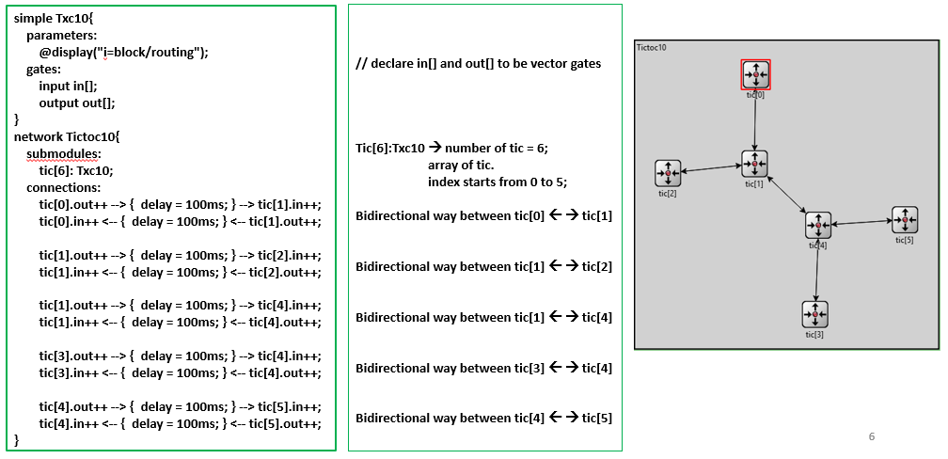Network Class: - Network class is consisting of submodule and connection. Submodule declare the nodes architecture in the network and which types of node they are. On the other hand, connection is used to declare how nodes are transmitted data in a given time parameter. You can change network design and color in this class.

Figure 1 NED file structure

1. Header file (.h file): - Header file is used to create methods for new class. In C/C++ header file uses to create relation between source file and NED file. It’s run in the background. It’s consists of different library program.
2. Program file (.c file): - This file is used for writing program in C/C++. In here simple modules are programmed in C++.
3. Message file (.msg files): - Message definition or .msg file is used to define various message types and add data fields to them. Omnet++ will convert this message into C++ classes.
4. Configure file (omnetpp.ini): - When a program first started it read the NED files, then omnetpp.ini file usually called. This configuration file has settings for network.

**Summary**

After analysis every single simulator which related to wireless sensor network we find Omnet++ is the most suitable for our research work. The most essential part to work with any simulator in WSN is that the understanding the code formation and also the support of different existing library. In here Omnet++ standout from all of them. Where ns-2 and ns-3 is really difficult to use because those simulators are run on different operating system or environment. Which everyone is not familiar with and installing ns-2 and ns-3 is very difficult job to do. Moreover ns-2 graphical user interface is not wall established. On the other hand, ns3 is comparatively new in the platform, so that its library is not sufficient to work on WSN protocols.

### MATLAB

MATLAB is known as “Matrix Laboratory” which is used for numerical computation and visualization. This enhanced the software for using linear algebra. It’s a great tool for solving different equations, algebraic and for numerical integration. It’s very popular to the scientific community. It’s helps us to easily work with entire matrices rather than one number at a time.

MATLAB is very unique and more user friendly for using matrix and vector manipulation. It’s comes with basic set of tools for visualizing data and for performing calculation on matrices and vectors.

Some MATLAB toolbox are given below: -

* Statistic toolbox.
* Neural Network toolbox.
* Fuzzy logic toolbox.
* Signal processing toolbox.
* Wavelet toolbox.
* Financial toolbox.
* Bio informatics toolbox.
* Database toolbox.

#### Features of MATLAB

* Manipulation and simplification of mathematical expression.
* Different symbolic integration, differentiation, transformation and linear algebra.
* 2D and 3D plotting for analytical equations and functions.
* ODE (Ordinary differential equation) solving mechanism.
* Different variable precision arithmetic's.
* Symbolic expression conversion to MATLAB, Simulink, Sims-cape, C, Fortran, and LaTeX.
* Different unit systems for specifying, converting and computing using SI, US and custom unit system.
* Packaging of MATLAB programs as standalone application.
* It can create Microsoft Excel add-ins for integration with excel spreadsheets.
* Application can be distributed for free.
* It has high encryption capability for intellectual property.
* MATLAB code can deploy against Hadoop and Spark.

## Techniques

### Localization Methods Taxonomy

Figure 2 Localization Taxonomy

### Cluster Formation

Wireless Sensor Networks (WSNs) are deployed over a target area to supervise certain phenomena of interest. In a cluster-based architecture, there are two distinct phases:

* The cluster formation phase
* The steady state phase

#### Cluster Formation Phase

Figure 3 Cluster Formation Phase

#### Taxonomy of Clustering Methods

Figure 4 Clustering Methods

### Aggregation

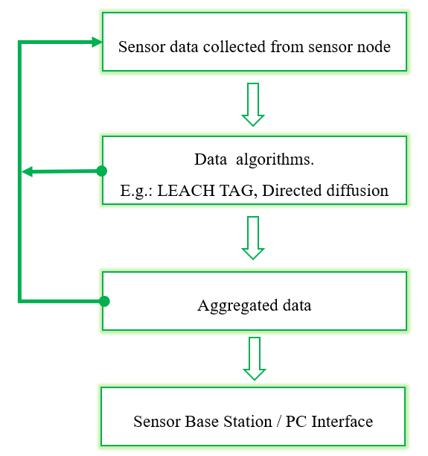

Figure 5 Data Aggregation Algorithm

### Multi-hop

The technique of multi-hop networks is there will be one or more intermediate nodes which will  
stay along the path that will receive and send the packets forward with the help of wireless links.  
By using Multi-hop wireless several benefits can be achieved. For example: It can improve the  
connectivity and extend the coverage area of the network compared to a network with single  
wireless links. It can also save power and energy as transmission over “short” links consumes less  
power than transmitting over “long” links. It makes the efficient use of the wireless medium as it  
enables higher data rates which result in higher throughput. It also prevents the wide deployment  
of cables. So, we can deploy it by which cost will be minimized. If the multi hop network is dense  
then several paths can be made available which can be used to increase the robustness of the  
network. There is a disadvantage in multi hop. The protocols that is developed for a network  
which is fixed like cellular as well as the internet are not optimal for multi-hop.

TCP should be supported in multi-hop wireless networks as well. However, many protocol  
mechanisms such as congestion control and error control based on acknowledgements do not work  
efficiently in multi-hop wireless networks due to some reasons for example contention and control  
packet overhead. Even on application level new concepts are required to support discovery of  
available applications and services. After investigating several application scenarios was found for  
multi-hop wireless networks. Recently, to provide broadband internet service without expensive  
cables, mesh networks is proposed. Wireless sensor networks are another emerging technology,  
can cover large geographical areas, and provide connectivity without having direct physical access to each sensor node. Sensor nodes can be configured and sensor data can be read using multi-hop  
networking.

### Single-hop

In a wireless sensor network most of the applications are dependent on a single-hop wireless network to send the data of a phenomena to Base station. That is the result of a measurement by a sensor are sent directly to BS. In most of the cases the applications are dependent on various kinds of sensor which are embedded into a device. For example, small sensors can be embedded into a traffic surveillance system to monitor traffic on congested roads or be used to monitor hot spots in a region or building.

Another famous example of wireless sensor network composed of embedded sensors is Health Care. The Health monitoring sensors are embedded into watches. When the patient wears this, the sensors sense the data such as pulse, blood pressure, heart beat etc. When it can sense any risk it also sends alarm messages to a nearby center using single-hop wireless sensor communication. As the sensors are powered by battery there is also used an intelligent and smart sensor power management system that helps to increase the energy efficiency and also quality of service (QoS).

## TDMA

Now a days it has been considered as the best choice for an energy efficient protocol which allow multiple access in wireless sensor networks. In TDMA there exist many approaches which of increased complexity, which use various kinds of algorithm and merging information from different layers or multiple access techniques. Nowadays there are many surveys which are finding out the advantages and disadvantages of different protocols, but we have a feeling that they cannot draw the general image of TDMA techniques, which can be helpful to choose the protocol for a network. Or for someone who is trying to establish e new MAC protocol. Now analyze various algorithms which are used in TDMA protocols and present a list of characteristics that a robust TDMA protocol requires.

## IEEE 802.15.4

The intention behind the development of IEEE 802.15.4 was to provide a framework, also the lower levels for low power networks which also cost low. It only provides two layers. They are the MAC layer and the PHY layer. The upper layers are developed considering the need of market.

The IEEE 802.15.4 standard might not be known widely like other higher layer standards, for example Zigbee, which is publicized massively. Nevertheless, the IEEE 802.15.4 technology and standard forms the basis and it gives a platform for their operation.

In recent days the usage of IEEE 802.15.4 technology is increasing continuously along with other famous technology like Zigbee. The importance of this standard is also increasing.

# Chapter 04: Methodology and Modeling

## Overview

Methodology includes the step by step process of how our work implemented and modeling refers to the elaborated description of methodology.

1. At first, the cluster head is selected based on the threshold value. ​
2. After the selection of cluster heads, we determine the hibernate nodes of cluster heads.
3. When the energy of the cluster head is less than a energy-limit value, the cluster head becomes a normal node.
4. At that time the hibernate node of that cluster head will come into play the role of Cluster Head.
5. Then again another hibernate node will be determined for the newly formed Cluster Head. Here we have ensured that the node which just played the role of Cluster Head will not be selected as Hibernate node immediately.
6. All the selected Cluster Heads and Hibernate nodes stored in a structure array.
7. This process is repeated till the all nodes of the network are dead.

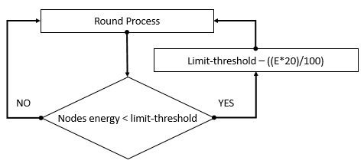

Figure 6 Round flow chart

## Network Parameters

Table 1 Network Parameters for simulation

|  |  |
| --- | --- |
| Network Parameters | Value |
| Network Size  Number of Nodes  Channel Type  Initial Energy of Sensor Nodes  Transceiver idle state energy consumption  Data Aggregation/ Fusion Energy consumption  Amplification Energy (Cluster to BS) d >= do  Amplification Energy (Cluster to BS) d <= do | 200 X 200 m2  100  Wireless Channel  0.5 J  50 nJ/bit  *EDA =* 5 nJ/bit/report $E_{fs}$ = 10pJ/bit/m2  = 0.0013 pJ/bit/m2 |

Energy consumption is based on three terms that are energy for free space and multipath and energy for data aggregation. Also amplifying energy is needed to proficiently pass the data.

**Individual Round Energy Consumption**

* Transceiver idle state energy consumption
* Same energy cost for these following steps:

|  |  |
| --- | --- |
| CH forming | Sent data to sink (BS) |
| CH remains as CH |
| H 🡪 CH shift |
| Here energy consumption is same as transmitting energy which is stated below | |

* When CH receives data, energy consumption is same as receiving energy which is stated below.

## First Order Radio Model

An illustration of the first order radio model is shown in figure below.

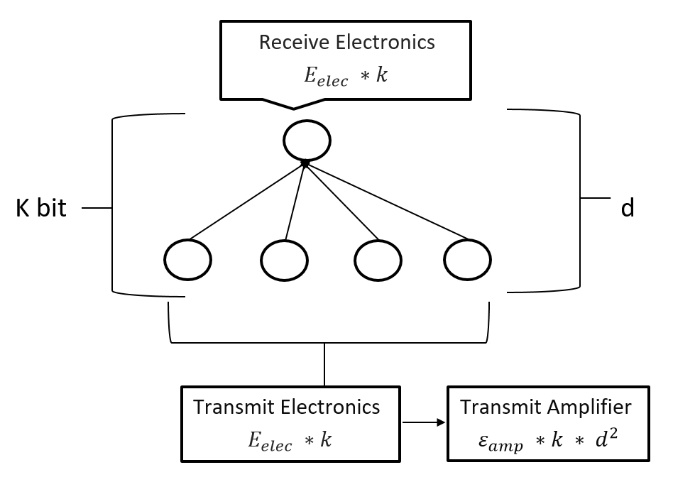

Figure 7 First Order Radio Model

|  |  |
| --- | --- |
| The energy consumption of transmitting a k-bit packet at a distance d can be expressed by [1]: | |
| $$E_{Tx}\left(k,d\right)=E_{elec}*k+ E_{fs} *k*d^{2} if(d≤d_{0})$$ | (1) |
| $$E_{Tx}\left(k,d\right)=E_{elec}*k+ ε_{amp} *k*d^{4} if(d>d_{0})$$ | (2) |
| Receiving a k-bit packet can be calculated by: | |
| $$E_{Rx}\left(k,d\right)=E_{elec}*k$$ | (3) |

Where,

$E_{elec}$ = *ETX + EDA or ERX + EDA*

*EDA* = required energy for data aggregation

$ε_{amp}$ = amplifying power to ensure the smooth operation

*k* = size of the transmitting or receiving packet

*d* = the distance between the sender node and receiver node

$d_{0}$ = a predefined value, which depends on the performance of the sensor node

## Node Deployment

Nodes placement of WSN regulate the effectiveness of the whole network in terms of parameters such as latency, power consumption, interference etc. However, as several WSN are deterministically deployed over an area of interest, it is very difficult to perform specific node placement [16].

Node deployment is the first step to form the network. Each node has 4 attributes.

Table 2 Node Attributes

|  |  |  |
| --- | --- | --- |
| Node | S(i).xd | Node coordinate in x-axis |
| S(i).ym | Node coordinate in x-axis |
| S(i).E | Initial node energy |
| S(i).type | Type of node ( N / CH / H ) |

In our forming network, total number of nodes is 200. Parameter values of all nodes are setting up by a for loop where coordinates are determined by rand () function and others are default values.

Now nodes deployed in the network. Base station is formed by default base station values.

## Cluster Head Selection

Let’s define how we generate cluster formation and how to select cluster head in our proposed method. First of all, we will define the network at the initial phase. After that the node have all the ability by itself if it wants to be a cluster or not in the current round. In here the decision will be made by analyzing the suggested cluster head based on threshold value. n node will choose the decision by generating random number using rand(). Now we find that if the number is less than threshold T (n), the node becomes a cluster-head for the current round.

|  |  |
| --- | --- |
| T (n) = $\frac{p}{1-p*\left\{r mod \frac{1}{p}\right\}}$ | (4) |

Where,

$p$ = the desired percentage of cluster heads (e.g., P = 0.1)

*r* = the current round

## Hibernate Node Formation

After forming cluster head matrix, we determine hibernate nodes for each cluster head. Hibernate nodes are selected based on the closest distance and greater energy value than energy-limit. Whenever a node is satisfied these conditions, it’ll become hibernate node for the according cluster head. When a hibernate node turns into cluster head, again hibernate node selected for this cluster head. This process is ongoing till the condition is dissatisfied.

Hibernate node characteristics:

* After selected as hibernate, it stays in idle state till turn into cluster head
* No sensing energy consumption
* Cost only idle state energy consumption

## Cluster Formation

After the formation of cluster heads and related hibernate node, cluster will be formed based on distance. Nodes of the network will be connected to the cluster head which is nearest.

## Dead Node Calculation

In our simulation total number of rounds is 1500. We are storing the specific round numbers at which the first node, 50% nodes and all nodes are dead.

|  |
| --- |
| Pseud code 1 Dead node calculation: |
| /* dead is the dead node counting variable and r is the round number */  if dead is 1 then  if flag_first_dead is 0 then  first_dead=r  flag_first_dead=1  end  end  /* 10% node of the whole network = 0.1*n */  /* where n is the total number of nodes */  if dead is 0.1*n then  if flag_teenth_dead is 0 then  teenth_dead=r  flag_teenth_dead=1  end  end  if dead is n then  if flag_all_dead is 0 then  all_dead=r  flag_all_dead=1  end  end |

If any node’s energy is less or equal to zero then dead count is increment gradually.

|  |  |
| --- | --- |
| 1ST NODE | When the first node of the network is dead, then first_dead=round and flag_first_dead=1. |
| 50% NODE | When 50% nodes of the WSN dead, then fifty_dead=r and flag_fifty_dead=1. |
| ALL NODE | When all nodes dead, then all_dead=r and flag_all_dead=1. |

As we need to visualize the node survival performance, we are storing these first node, 50% nodes and all nodes dead counts in STATISTIC.DEAD and STATISTICS.ALIVE array.

## Network Total Energy Calculation

Total energy is the summation of all nodes energy.

In each round, using for loop, we store total energy in the TotalNetworkEnergy variable.

|  |
| --- |
| Pseuducode: Total Energy Calculation |
| /* n is the total number of nodes */  /* S(i).E is the individual energy of each node */  for i=1 to n  if S(i).E is greater than 0 then  TotalNetworkEnergy=TotalNetworkEnergy+S(i).E;  end  end |

As we need to visualize the total network energy, we store the value in STATISTIC.TotalEnergy and STATISTICS.AvgEnergy array.

# Chapter 05: Structure Profile

## Overview

To simulate our proposed LEACH routing protocol, we used OMNET++.

OMNeT++ is a component-based, modular and open-architecture discrete event network simulator. OMNeT++ represents a framework approach

* Instead of containing explicit and hardwired support for computer networks or other areas, it provides an infrastructure for writing such simulations
* Specific application areas are catered by various simulation models and frameworks, most of them open source.

## Simulation Model Building

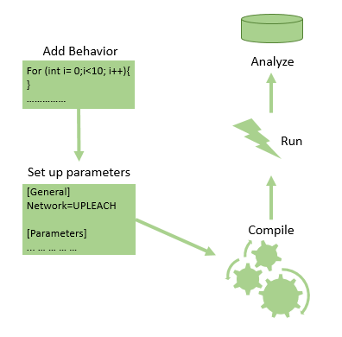

Figure 8 Simulation Model Building

## Build Process

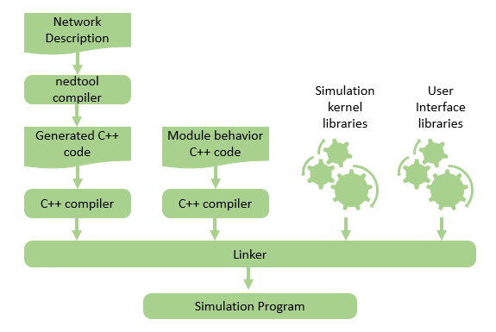

Figure 9 Build Process of Omnetpp Simulation

## Simulation Phases

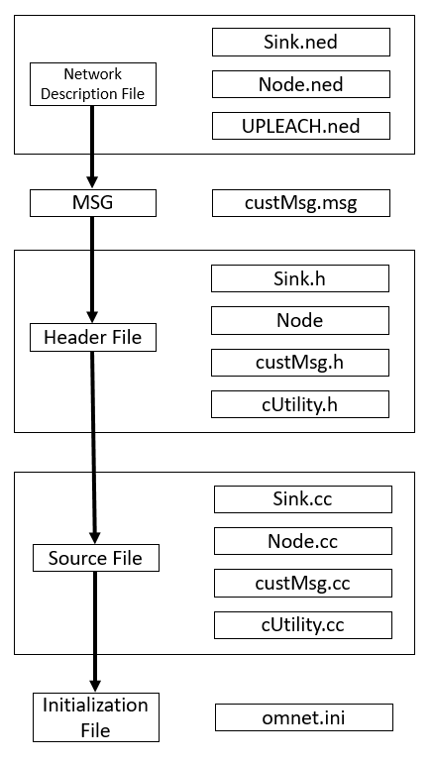

Figure 10 Simulation Phases

## NED

**UPLEACH.ned**

This is the file for each node describes the input and output gates.

**package** UPLEACHPckg;

**network** UPLEACH

{

**parameters**:

**int** roundNumber = **default**(0);

**double** totalRemainingEnergy = **default**(0);

**double** avgRemainingEnergy = **default**(0);

**double** lastRoundTime = **default**(0);

**double** clusterHeadPercentage = **default**(0.1);

**int** noOfCH = **default**(0);

**int** noOfCluster = **default**(0);

**string** lstCH = **default**("0");

**int** sinkX = **default**(80); *//old = 230*

**int** sinkY = **default**(20); *//old = 40*

*//1=Setup, 2=Data send to CH, 3=Data Send to Sink*

**int** networkStatus = **default**(0);

**int** netSizeX = **default**(200);

**int** netSizeY = **default**(200);

**int** noOfNodeDied = **default**(0);

**int** fstNodeDieRound = **default**(0);

**int** tenNodeDieRound = **default**(0);

**int** allNodeDieRound = **default**(0);

*//Added for throughput*

**int** noDataSentToCH = **default**(0);

**int** noDataSentToSink = **default**(0);

**int** noDataInSink = **default**(0);

**int** noPacketSentToSink = **default**(0);

**int** sendPacketToCH = **default**(0);

**int** noOfWirelessNode **@prompt**("Number of Nodes") = **default**(2);

*//@display("bgb=netSizeX,netSizeY");*

*//@display("bgb=800,600");*

**@display**("bgb=200,200");

**submodules**:

sink: Sink;

node[noOfWirelessNode]: Node {

**@display**("i=misc/node_vs,gold;p=230,140");

}

}

**Node.ned**

This is the file for each node describes the input and output gates.

**package** UPLEACHPckg;

**simple** Node

{

**gates**:

**input** radioIn **@directIn**; *// work as input and output*

}

**Sink.ned**

This is the file for the sink describes the input and output gates.

**package** UPLEACHPckg;

**simple** Sink

{

**gates**:

**input** radioIn **@directIn**;

}

## Message Definition

**custMsg.msg**

*//enum PacketType{*

*// RTS_DATA = 0; //request to send*

*// CTS_DATA = 1; //clear to send*

*//};*

**packet** custMsg{

**int** sourceId; *//Initial source id of the message*

**int** messageId; *//Unique message id for each message*

**int** ackMsgId; *//Message Id, which acknowledgemnt is send*

**int** senderId; *//Immediate sender id of the message*

**int** intendedReceiverId; *//Message intended receiver id*

**double** packetGenerateTime; *//Initial packet or message generation time*

**double** packetReachToSinkTime;

**bool** isRelayMsg; *//Is this message a relay message or not*

**double** packetReachTime;

**double** overheadDelay;

};

## Header File and Source File

A header file is a file with extension .h which contains C function declarations and macro definitions to be shared between several source files. There are two types of header files: the files that the programmer writes and the files that comes with your compiler.

**Header file:**

#include <headerFile>

Class ClassName: public inheitedModule{

Public:  
 variables;

Constructor;

Destructor;

Private/protected:

methodName (parameter);

}

**Source file:**

#include <headerFile>

Define_Module(ModuleName), //Defining user created header files.

//Definition of all methods declared in header file. Like as,

ModuleName :: methodName(Parameter){

Method Definition

}

The header files and related source files that we are used to simulate our routing protocol are briefly depicted below.

**Node.h**

**#ifndef** NODE_H_

**#define** NODE_H_

**#include** <omnetpp.h>

**#include** <Sink.h>

**#include** <custMsg_m.h>

**class** Node: **public** cSimpleModule {

**public**:

Variables

**Node**();

**virtual** **~Node**();

**private**:

**void** **SetCoordinate**();

**void** **ClusterHeadSelection**(**int** roundNo);

**void** **ClusterFormation**(**int** roundNo);

**void** **ResetG**(**int** roundNo);

**int** **CalculateDistanceToBS**(**int** nodeindex);

custMsg* **CreateCustMsg**(**const** **char** *name);

**int** **CalculateDistance**(**int** senderIndex, **int** receiverIndex);

**void** **SendDataToCH**();

**void** **SendDataToSink**();

**void** **WriteDeadNodeHistory**(**int** noOfDeadNode, **int** roundNumber);

**void** **WriteOneTenAllNodeDeadHistory**();

**void** **WriteNetworkEnergyHistory**(**int** roundNumber);

**void** **CountSinkPacket**(**int** roundNumber);

**void** **CountCH**(**int** roundNumber, **int** noOfCH); //Cound CH vs Round

**void** **TempDataSendToCH**();

**void** **TempDataSendToSink**();

**void** **ThresholdCheck**();

//New added for throughput calculation

**void** **CountThroughput**(**int** roundNumber);

**void** **ResetParam**();

**protected**:

**virtual** **void** **initialize**();

**virtual** **void** **handleMessage**(cMessage *msg);

**void** **finish**();

};

**#endif** /* NODE_H_ */

**Sink.h**

**#ifndef** SINK_H_

**#define** SINK_H_

**#include** <omnetpp.h>

**#include** <custMsg_m.h>

**class** Sink: **public** cSimpleModule {

**public**:

**Variables;**

**Sink**();

**virtual** **~Sink**();

**private**:

**void** **SetCoordinate**();

custMsg* **CreateCustMsg**(**const** **char** *name);

**protected**:

**virtual** **void** **initialize**();

**virtual** **void** **handleMessage**(cMessage *msg);

};

**#endif** /* SINK_H_ */

**cUtility.h**

**#ifndef** CUTILITY_H_

**#define** CUTILITY_H_

**#include** <vector>

**#include** <string>

**class** cUtility {

**public**:

**cUtility**();

**virtual** **~cUtility**();

std::string **getTestMsg**();

std::vector<std::string> **split**(**const** std::string& str, **const** **char**& ch);

std::vector<**int**> **convertToInt**( std::vector < std::string > vStr);

};

**#endif** /* CUTILITY_H_ */

**custMsg_m.h**

**#ifndef** _CUSTMSG_M_H_

**#define** _CUSTMSG_M_H_

**#include** <omnetpp.h>

**class** custMsg : **public** ::cPacket{

**protected**:

**//Variables**

**private**:

**void** **copy**(**const** custMsg& other);

**protected**:

// protected and unimplemented operator==(), to prevent accidental usage

**bool** **operator==**(**const** custMsg&);

**public**:

**custMsg**(**const** **char** *name=NULL, **int** kind=0);

**custMsg**(**const** custMsg& other);

**virtual** **~custMsg**();

custMsg& **operator=**(**const** custMsg& other);

**virtual** custMsg \***dup**() **const** {**return** **new** custMsg(\***this**);}

**virtual** **void** **parsimPack**(cCommBuffer *b);

**virtual** **void** **parsimUnpack**(cCommBuffer *b);

// field getter/setter methods

**virtual** **int** **getSourceId**() **const**;

**virtual** **void** **setSourceId**(**int** sourceId);

**virtual** **int** **getMessageId**() **const**;

**virtual** **void** **setMessageId**(**int** messageId);

**virtual** **int** **getAckMsgId**() **const**;

**virtual** **void** **setAckMsgId**(**int** ackMsgId);

**virtual** **int** **getSenderId**() **const**;

**virtual** **void** **setSenderId**(**int** senderId);

**virtual** **int** **getIntendedReceiverId**() **const**;

**virtual** **void** **setIntendedReceiverId**(**int** intendedReceiverId);

**virtual** **double** **getPacketGenerateTime**() **const**;

**virtual** **void** **setPacketGenerateTime**(**double** packetGenerateTime);

**virtual** **double** **getPacketReachToSinkTime**() **const**;

**virtual** **void** **setPacketReachToSinkTime**(**double** packetReachToSinkTime);

**virtual** **bool** **getIsRelayMsg**() **const**;

**virtual** **void** **setIsRelayMsg**(**bool** isRelayMsg);

**virtual** **double** **getPacketReachTime**() **const**;

**virtual** **void** **setPacketReachTime**(**double** packetReachTime);

**virtual** **double** **getOverheadDelay**() **const**;

**virtual** **void** **setOverheadDelay**(**double** overheadDelay);

};

**inline** **void** **doPacking**(cCommBuffer *b, custMsg& obj) {obj.parsimPack(b);}

**inline** **void** **doUnpacking**(cCommBuffer *b, custMsg& obj) {obj.parsimUnpack(b);}

**#endif** // _CUSTMSG_M_H_

# Chapter 06: Mathematical Analysis & Data Sheet

## Mathematical Analysis

* In idle state:

per round energy consumption = 0.000000005J

1000 round energy consumption = 1000 * 0.000000005 = 0.000005J

* Suppose, Message size = 4000bit.

d0 = 50m

d1= 20m

d2= 60m

* Required energy to receive:

receiving energy = *( ERX + EDA ) * 4000*

= {( 0.000000005 + 0.000000005) * 4000 }

= 0.00004J

* Required energy to transmit:
  + for d1, if(d<=d0) then

transmit energy = *( ETX + EDA ) * 4000 + Efs * 4000 * d2*

transmit energy = {( 0.000000005 + 0.000000005) * 4000 }

+ ( 0.000000000001 * 4000 * 202)

= 0.0000416J [Lowest energy consumption for single transmission]

* + for d2, if(d>d0) then

transmit energy = *( ETX + EDA ) * 4000 + * 4000 * d4*

transmit energy = {( 0.000000005 + 0.000000005) * 4000 }

+ ( 0.000000000000013*4000* 604 )

= 0.00071392J [Highest energy consump. for single transmission]

* Hibernate node’s energy remains almost same till they turned into CH.
* Suppose, a CH remains as CH for 10 rounds. For these 10 rounds, linked hibernate node have no energy dissipation. So, its energy remains same for 10 rounds i.e. till convert to CH.

H.E = 0.0000416 (Lowest energy dissipation per round)

10 rounds will cost = 10 * 0.0000416 = 0.000416 J

H.E = 0.00071392 (Highest energy dissipation per round)

10 rounds will cost = 10 * 0.00071392 = 0.0071392 J

* If total round is 1000, then Hibernate node’s energy remains same for 100times.

So, for 1000 round,

H.E = 0.000416 * 100 = 0.0416 (Lowest energy dissipation)

H.E = 0.0071392 * 100 = 0.71392 (Highest energy dissipation)

This energy is saved in 1000 rounds for single CH.

* If there are 10 CH, then

Total lowest energy dissipation = 0.0416 * 10 = 0.416 J [0.83% of total network energy]

Total highest energy dissipation = 0.71392 * 10 = 7.1392 J [14% of total network energy]

By this energy, the network can run another 100+ rounds.

But in simulation around 8%-10% energy saved that enhance the network lifetime.

## Graphical Data

Figure 11 Dead node per round

Figure 10 shows how many nodes died per round. After all nodes are dead, the above figure formed.

Figure 12 Alive node per round

Figure 11 shows how many nodes alive per round. After all nodes are dead, the above figure formed.

Figure 13 Residual Energy per round

Figure 12 shows that residual energy per round consist in the simulation

Figure 14 Alive node per round

Figure 13 shows that the energy consumption rate per round. This figure formed for energy consumption rate.

Packet Sent to BS

Figure 15 Packet sent to BS over round

## First Iteration Cluster Head Data

Table 3 First Iteration Cluster Head Matrix

|  |  |  |  |
| --- | --- | --- | --- |
| xd | Yd | distance | id |
| 85.27281 | 89.30603 | 159.4223 | 12 |
| 234.9289 | 311.1384 | 116.4979 | 25 |
| 220.3239 | 368.359 | 169.5813 | 35 |
| 264.717 | 221.9252 | 68.3301 | 39 |
| 317.2354 | 302.1898 | 155.5214 | 49 |
| 272.9212 | 259.7236 | 94.25715 | 52 |
| 369.7098 | 39.90836 | 233.304 | 56 |
| 364.7339 | 369.4003 | 236.2916 | 58 |
| 361.7166 | 293.9417 | 187.0222 | 62 |
| 337.3407 | 361.9637 | 212.3552 | 63 |
| 397.3383 | 391.6698 | 275.0995 | 89 |
| 212.6977 | 397.4296 | 197.8375 | 92 |

## Initial Node Data

Table 4 Initial Node Data

|  |  |  |  |  |  |
| --- | --- | --- | --- | --- | --- |
| Node no. | xd | Yd | G | E | Type |
| 1 | 102.166 | 3.833639 | 0 | 0.5 | 'N' |
| 2 | 85.37524 | 150.8607 | 0 | 0.5 | 'N' |
| 3 | 291.7285 | 242.4021 | 0 | 0.5 | 'N' |
| 4 | 351.2713 | 306.8977 | 0 | 0.5 | 'N' |
| 5 | 318.094 | 156.2672 | 0 | 0.5 | 'N' |
| 6 | 309.6087 | 136.8943 | 0 | 0.5 | 'N' |
| 7 | 345.8744 | 178.5242 | 0 | 0.5 | 'N' |
| 8 | 75.20984 | 23.03572 | 0 | 0.5 | 'N' |
| 9 | 88.1282 | 89.12509 | 0 | 0.5 | 'N' |
| 10 | 267.23 | 369.4559 | 0 | 0.5 | 'N' |
| 11 | 222.1021 | 309.7797 | 0 | 0.5 | 'N' |
| 12 | 120.0114 | 341.702 | 0 | 0.5 | 'N' |
| 13 | 6.075038 | 0.292134 | 0 | 0.5 | 'N' |
| 14 | 76.15722 | 371.7983 | 0 | 0.5 | 'N' |
| 15 | 364.5683 | 43.82225 | 0 | 0.5 | 'N' |
| 16 | 203.1643 | 371.473 | 0 | 0.5 | 'N' |
| 17 | 38.31476 | 351.0816 | 0 | 0.5 | 'N' |
| 18 | 377.7863 | 236.5216 | 0 | 0.5 | 'N' |
| 19 | 110.3374 | 74.79533 | 0 | 0.5 | 'N' |
| 20 | 291.1436 | 174.0962 | 0 | 0.5 | 'N' |
| 21 | 141.9345 | 302.2056 | 0 | 0.5 | 'N' |
| 22 | 141.6649 | 252.9034 | 0 | 0.5 | 'N' |
| 23 | 176.8423 | 123.2508 | 0 | 0.5 | 'N' |
| 24 | 350.0036 | 243.0994 | 0 | 0.5 | 'N' |
| 25 | 226.1958 | 239.628 | 0 | 0.5 | 'N' |
| 26 | 247.6692 | 339.5051 | 0 | 0.5 | 'N' |
| 27 | 265.8117 | 18.15776 | 0 | 0.5 | 'N' |
| 28 | 307.9608 | 340.5657 | 0 | 0.5 | 'N' |
| 29 | 279.1162 | 375.2162 | 0 | 0.5 | 'N' |
| 30 | 271.1073 | 56.92309 | 0 | 0.5 | 'N' |
| 31 | 110.3124 | 81.60735 | 0 | 0.5 | 'N' |
| 32 | 86.68647 | 385.2044 | 0 | 0.5 | 'N' |
| 33 | 318.3632 | 173.8405 | 0 | 0.5 | 'N' |
| 34 | 328.8082 | 16.63628 | 0 | 0.5 | 'N' |
| 35 | 366.538 | 70.71094 | 0 | 0.5 | 'N' |
| 36 | 368.9428 | 107.4144 | 0 | 0.5 | 'N' |
| 37 | 255.6308 | 12.69342 | 0 | 0.5 | 'N' |
| 38 | 133.5811 | 356.3199 | 0 | 0.5 | 'N' |
| 39 | 118.7306 | 163.0645 | 0 | 0.5 | 'N' |
| 40 | 212.0819 | 268.4767 | 0 | 0.5 | 'N' |
| 41 | 214.7827 | 257.8671 | 0 | 0.5 | 'N' |
| 42 | 209.4637 | 197.7457 | 0 | 0.5 | 'N' |
| 43 | 146.9751 | 246.3687 | 0 | 0.5 | 'N' |
| 44 | 270.5574 | 101.1367 | 0 | 0.5 | 'N' |
| 45 | 145.5633 | 114.5202 | 0 | 0.5 | 'N' |
| 46 | 329.6573 | 89.09689 | 0 | 0.5 | 'N' |
| 47 | 149.091 | 288.3692 | 0 | 0.5 | 'N' |
| 48 | 114.9124 | 157.8806 | 0 | 0.5 | 'N' |
| 49 | 279.9568 | 301.6306 | 0 | 0.5 | 'N' |
| 50 | 141.2409 | 233.231 | 0 | 0.5 | 'N' |
| 51 | 223.9161 | 1.743209 | 0 | 0.5 | 'N' |
| 52 | 17.3795 | 298.039 | 0 | 0.5 | 'N' |
| 53 | 255.6283 | 97.43267 | 0 | 0.5 | 'N' |
| 54 | 300.1765 | 356.5316 | 0 | 0.5 | 'N' |
| 55 | 283.7901 | 320.1344 | 0 | 0.5 | 'N' |
| 56 | 259.7991 | 0.934927 | 0 | 0.5 | 'N' |
| 57 | 145.0607 | 46.84334 | 0 | 0.5 | 'N' |
| 58 | 258.2049 | 8.085621 | 0 | 0.5 | 'N' |
| 59 | 388.3289 | 108.4352 | 0 | 0.5 | 'N' |
| 60 | 99.96274 | 20.45498 | 0 | 0.5 | 'N' |
| 61 | 293.06 | 100.8456 | 0 | 0.5 | 'N' |
| 62 | 287.4829 | 141.808 | 0 | 0.5 | 'N' |
| 63 | 110.9599 | 146.4771 | 0 | 0.5 | 'N' |
| 64 | 371.5992 | 179.4505 | 0 | 0.5 | 'N' |
| 65 | 122.1121 | 250.3741 | 0 | 0.5 | 'N' |
| 66 | 58.86406 | 135.894 | 0 | 0.5 | 'N' |
| 67 | 149.9166 | 47.05659 | 0 | 0.5 | 'N' |
| 68 | 240.2595 | 273.6178 | 0 | 0.5 | 'N' |
| 69 | 21.5656 | 36.41644 | 0 | 0.5 | 'N' |
| 70 | 235.1618 | 208.726 | 0 | 0.5 | 'N' |
| 71 | 347.2326 | 205.2634 | 0 | 0.5 | 'N' |
| 72 | 3.551328 | 37.87739 | 0 | 0.5 | 'N' |
| 73 | 62.19526 | 32.86026 | 0 | 0.5 | 'N' |
| 74 | 300.0718 | 397.3195 | 0 | 0.5 | 'N' |
| 75 | 47.41371 | 98.55096 | 0 | 0.5 | 'N' |
| 76 | 231.4998 | 90.96634 | 0 | 0.5 | 'N' |
| 77 | 252.1529 | 162.691 | 0 | 0.5 | 'N' |
| 78 | 338.7678 | 198.8427 | 0 | 0.5 | 'N' |
| 79 | 233.3454 | 179.9087 | 0 | 0.5 | 'N' |
| 80 | 146.4537 | 131.8463 | 0 | 0.5 | 'N' |
| 81 | 321.0696 | 68.5957 | 0 | 0.5 | 'N' |
| 82 | 86.727 | 270.41 | 0 | 0.5 | 'N' |
| 83 | 81.73611 | 358.0016 | 0 | 0.5 | 'N' |
| 84 | 18.08999 | 273.7694 | 0 | 0.5 | 'N' |
| 85 | 133.2797 | 148.7171 | 0 | 0.5 | 'N' |
| 86 | 4.419726 | 231.5909 | 0 | 0.5 | 'N' |
| 87 | 388.3822 | 140.5773 | 0 | 0.5 | 'N' |
| 88 | 118.5303 | 359.3251 | 0 | 0.5 | 'N' |
| 89 | 319.7728 | 146.8171 | 0 | 0.5 | 'N' |
| 90 | 201.0603 | 381.2835 | 0 | 0.5 | 'N' |
| 91 | 212.1098 | 297.752 | 0 | 0.5 | 'N' |
| 92 | 180.8382 | 37.95115 | 0 | 0.5 | 'N' |
| 93 | 100.8692 | 59.97844 | 0 | 0.5 | 'N' |
| 94 | 50.5104 | 393.211 | 0 | 0.5 | 'N' |
| 95 | 160.3906 | 131.8866 | 0 | 0.5 | 'N' |
| 96 | 250.496 | 339.632 | 0 | 0.5 | 'N' |
| 97 | 297.7151 | 115.8513 | 0 | 0.5 | 'N' |
| 98 | 246.8287 | 320.5072 | 0 | 0.5 | 'N' |
| 99 | 198.5763 | 118.2512 | 0 | 0.5 | 'N' |
| 100 | 186.0584 | 340.3087 | 0 | 0.5 | 'N' |

# Chapter 07: Result

## Total Performance Evaluation

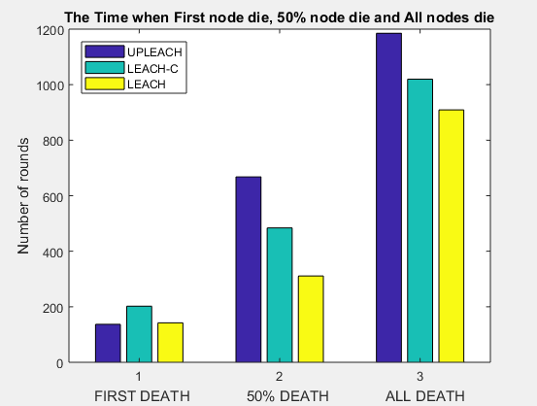

Figure 16 Comparison of 1st, half and all node death among LEACH distributions

Fig 16, it shows that our leach protocol performs well when we compare with “LEACH “and “LEACH-C” routing protocol. 50% nodes are dead around 300, 500 and 700 rounds in LEACH, LEACHC and UPLEACH that 14% better than LEACHC and 23% better than LEACH.

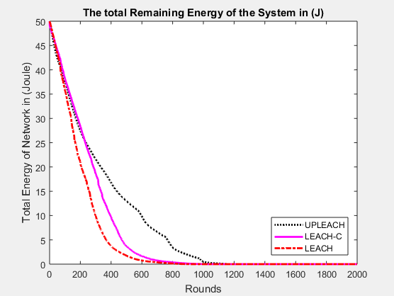

Figure 17 Network residual energy per round

Fig 17, shows the residual energy falling per round. LEACH and LEACHC total network energy is empty around 800 round where UPLEACH total network energy is empty around 1100 round.

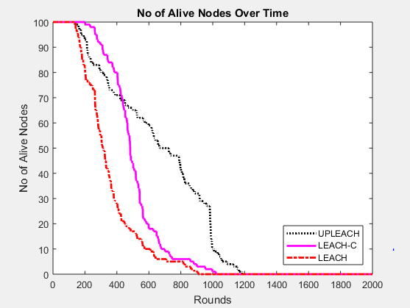

Figure 18 Alive node decreasing per round

The fig 18, discriminates the alive nodes per round rates among LEACH, LEACHC and UPLEACH that after 30 nodes death, UPLEACH outperformes the survivallity till the end.

# Chapter 08: Conclusion

In our thesis, we have shown a different approach of cluster head formation techniques. By upgrading the leach protocol, we can see the efficiency in the result. In here our “LEACH” protocol perform higher in terms of energy efficiency and nodes survival ratio. Both the analytical and simulation result show that the extended life time of WSN can be achieved with this novel approach. However, our goal is to achieve an efficient wireless node charging module to enhance the life time of sensor node in future. Moreover, we intend to develop an energy station which recharges the energy nodes that lead to an immortal WSN.

# References

|  |  |
| --- | --- |
| [1] | W. Heinzelman, A. Chandrakasan, and H. Balakrishnan.“Energy-Efficient Communication Protocols for Wireless Microsensor Networks”. *In Proceedings of Hawaiian International Conference on Systems Science*, January 2000. |
| [2] | Amit Karmaker; Md. Mahedee Hasan; y,Shafika Showkat Moni and Mohammad Shah Alam.“An Efficient Cluster Head Selection Strategy for Provisioning Fairness in Wireless Sensor Networks” *IEEE International WIE Conference on Electrical and Computer Engineering (WIECON-ECE)*, December 2016, AISSMS, Pune, India |
| [3] | D. Mahmood, N. Javaid1, S. Mahmood, S. Qureshi, A. M. Memon, T. Zaman, “MODLEACH: A Variant of LEACH for WSNs”, *Eighth International Conference on Broadband and Wireless Computing, Communication and Applications* |
| [4] | Fareed, M.S.; Javaid, N.; Ahmed, S.; Rehman, S.; Qasim, U.; Khan, Z.A., “Analyzing Energy-Efficiency and Route-Selection of Multi-level Hierarchal Routing Protocols in WSNs”, Broadband, Wireless Computing, Communication and Applications (BWCCA), *2012 Seventh International Conference*, vol., no., pp.626,631, 12-14 Nov. 2012. |
| [5] | V. Mhatre and C. Rosenberg, “Design Guidelines for Wireless Sensor Networks: Communication, Clustering and Aggregation”, Ad Hoc Networks, 2(1), 2004, pp.45-63. |
| [6] | M. M. Zanjireh, A. Shahrabi, and H. Larijani,” ANCH: A New Clustering Algorithm for Wireless Sensor Networks,” *In 27th International Conference on Advanced Information Networking and Applications Workshops (WAINA)*, pp. 450-455, 2013. |
| [7] | A. Patra and S. Chouhan,” Energy efficient hybrid multihop clustering algorithm in wireless sensor networks,” *In International Conference on Communication, Networks and Satellite*, pp. 59-63 Dec. 2013. |
| [8] | W. B. Heinzelman, A. P. Chandrakasan, and H. Balakrishnan, ”AnApplication-Specific Protocol Architecture for Wireless Microsensor- Networks,” *IEEE Transactions on Wireless Communications*,vol.1, no. 4, pp. 660-670, 2002. |
| [9] | C. Y. Chong and S. P. Kumar, “Sensor Networks: Evolution, Opportunities and Challenges”, Proceedings of the IEEE, 91, No. 8, pp. 1247-1256, Aug 2003. |
| [10] | M. Younis, P. Munshi, G. Gupta and S. M. Elsharkawy, “On Efficient Clustering of Wireless Sensor Networks”, *Second IEEE Workshop on Dependability and Security in Sensor Networks and Systems*, 2006, pp. 78-91. |
| [11] | S. V. K. a. A. Pal, "Assisted-Leach (A-Leach) Energy Efficient Routing Protocol for Wireless Sensor Networks*," International Journal of Computer and Communication Engineering*, vol. Vol. 2, 4, July 2013. |
| [12] | M. S. A. A. K. SHAW, "Transmission Time and Throughput analysis of EEE LEACH, LEACH and Direct Transmission Protocol: A Simulation Based Approach," *Advanced Computing: An International Journal (ACIJ)*, vol. Vol.3, p. 5, September 2012. |
| [13] | B. N. N. A. W. A. K. Salim EL KHEDIRIa, "A New Approach for Clustering in Wireless Sensors Networks Based on LEACH," *International Workshop on Wireless Networks and Energy Saving Techniques (WNTEST)*, 2014. |
| [14] | M. A. G. Leena Y.Barai, "Performance Evaluation of LEACH Protocol for Wireless Sensor Network," *International Journal of Innovative Research in Advanced Engineering (IJIRAE)*, vol. vol 1, no. 6, 2014. |
| [15] | X. Y. Xiaowen Maa, "Improvement on LEACH Protocol of Wireless Sensor Network," *Trans Tech Publications, Switzerland*, Vols. 47-350, 2013. |
| [16] | G. Horvat, D. Zagar and D. Vinko, "Influence of node deployment parameters on QoS in large-scale WSN," in *3rd Mediterranean Conference on Embedded Computing (MECO)*, Montenegro , 2014 |
| [17] | Amit Parmar, and Ankit Thakkar, “An improved modified LEACH-C algorithm for energy efficient routing in Wireless Sensor Networks”, *Nirma University Journal of Engineering and Technology*, VOL. 4, N0. 2, JUL-DEC 2015 |